Git and GitHub Day-1 Tasks
1.) watch the video and write notes.
Watched the video & taken the clear notes on my understanding.
2.) Create a GitHub account.
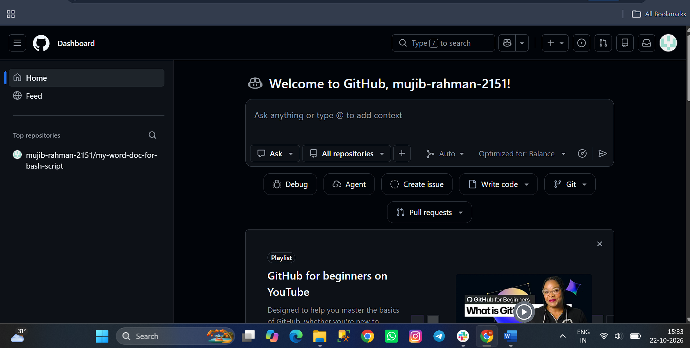
3.) set up MFA (Multi-Factor Authentication) for the GitHub account using a mobile app.
Step :1 login to the github Account
Step:2 Go to settings
Step:3 Password and Authentication
Step:4 There we can find Enable two factor Authentication. (Authenticator I used which is available in playstore)
Step:5 In addition to that, we can add passkeys also while signing in.
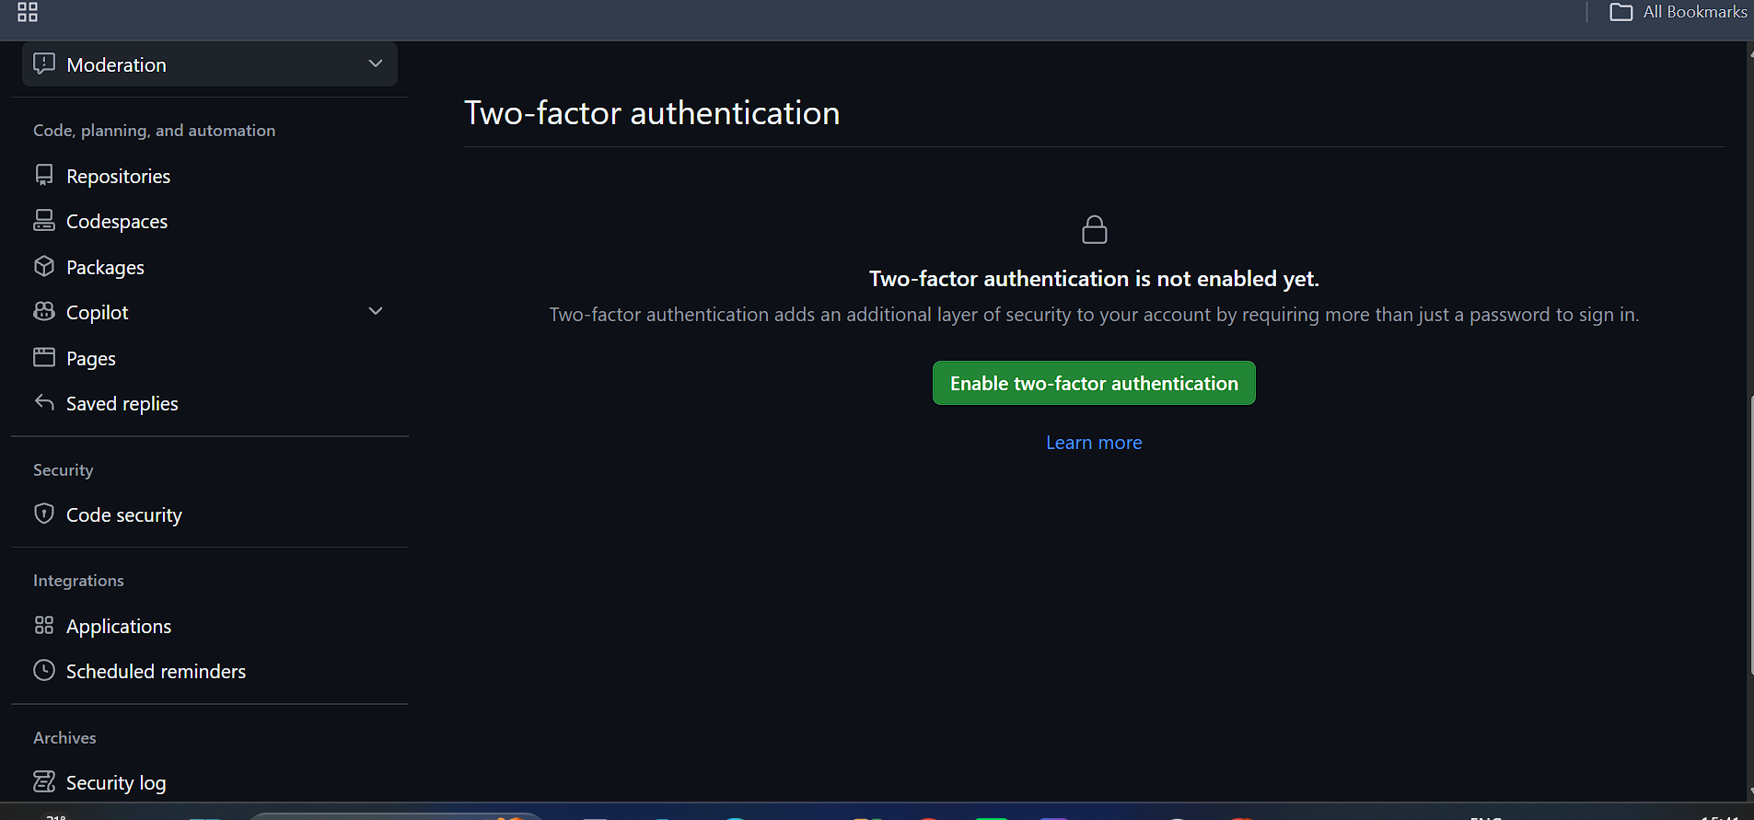
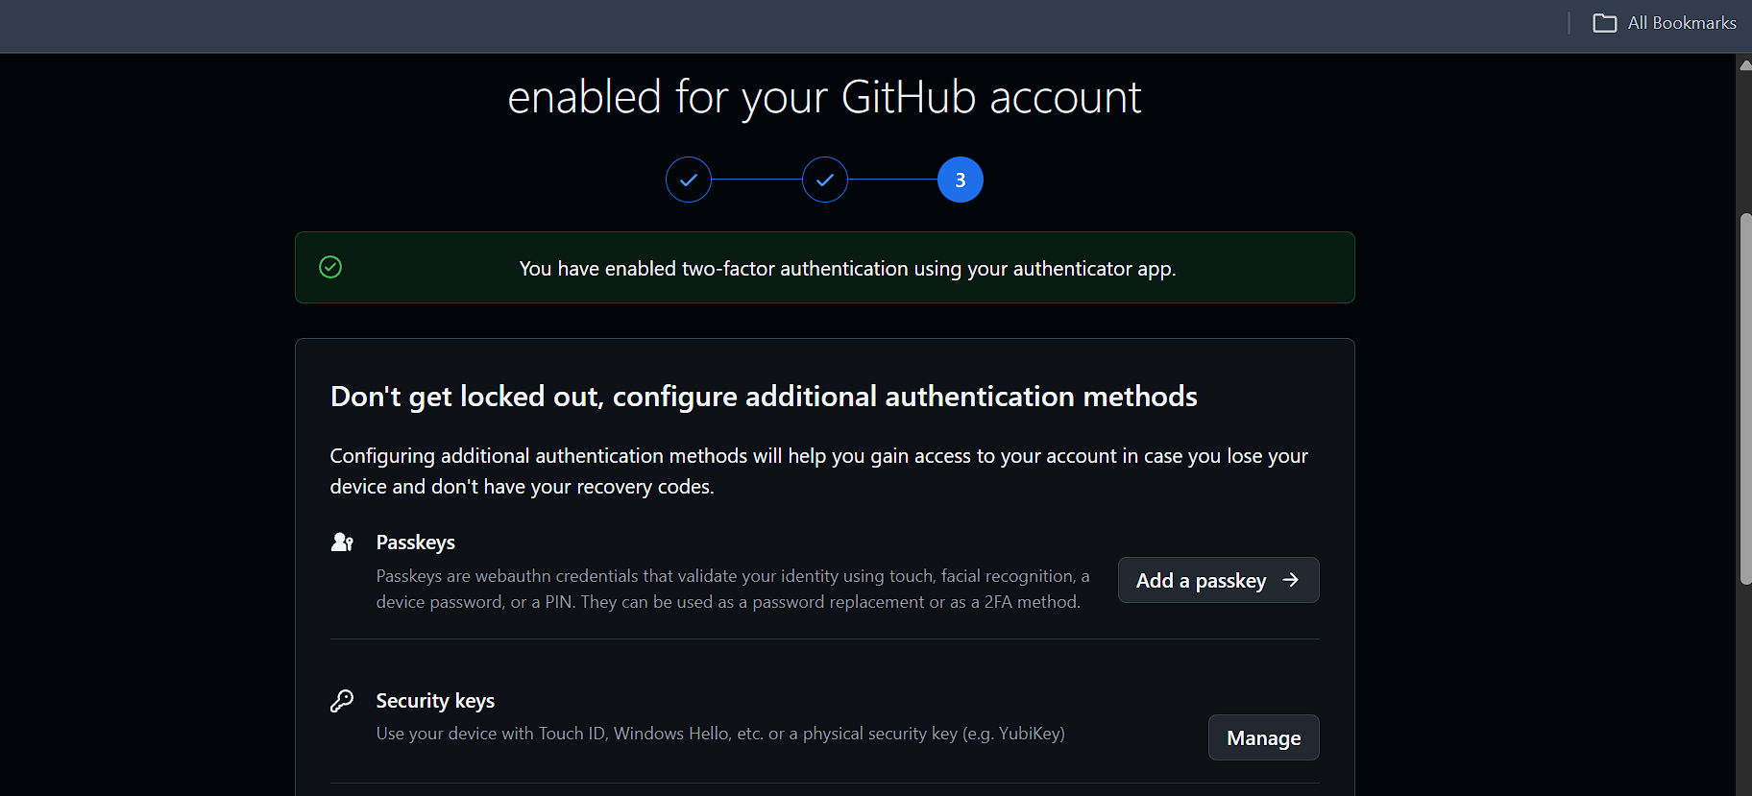
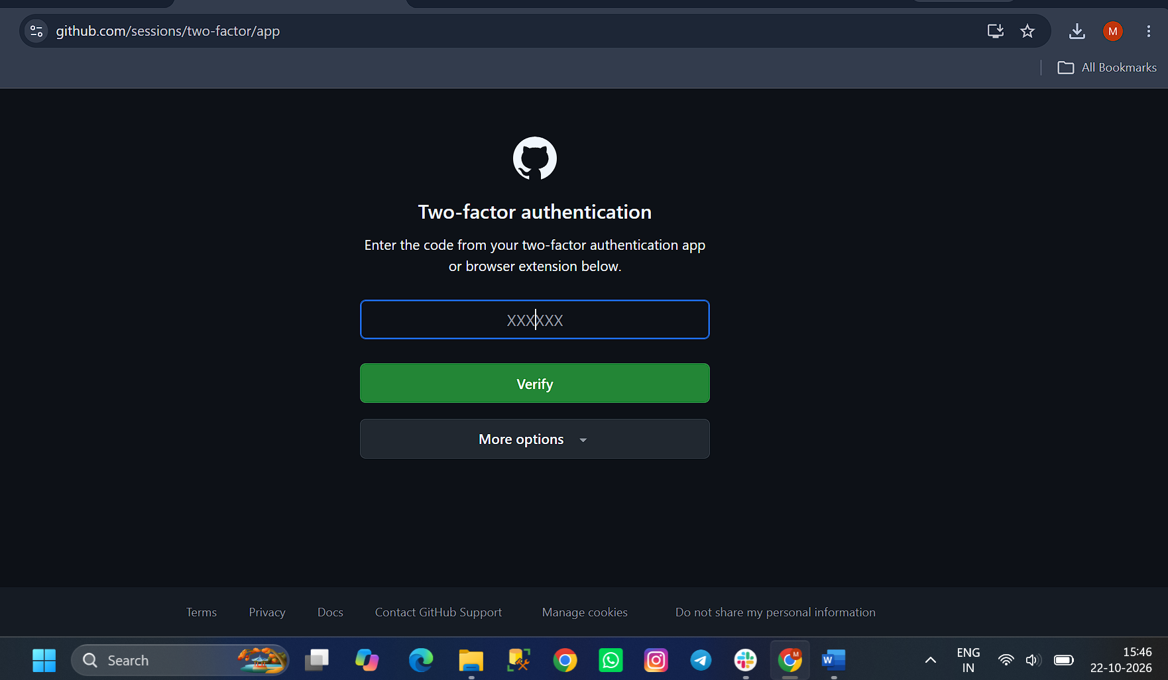
4.) execute all commands shown in the video.
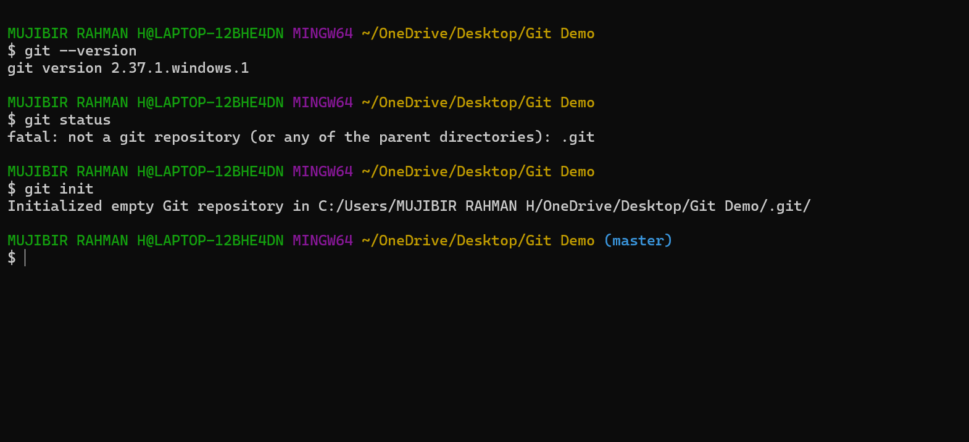
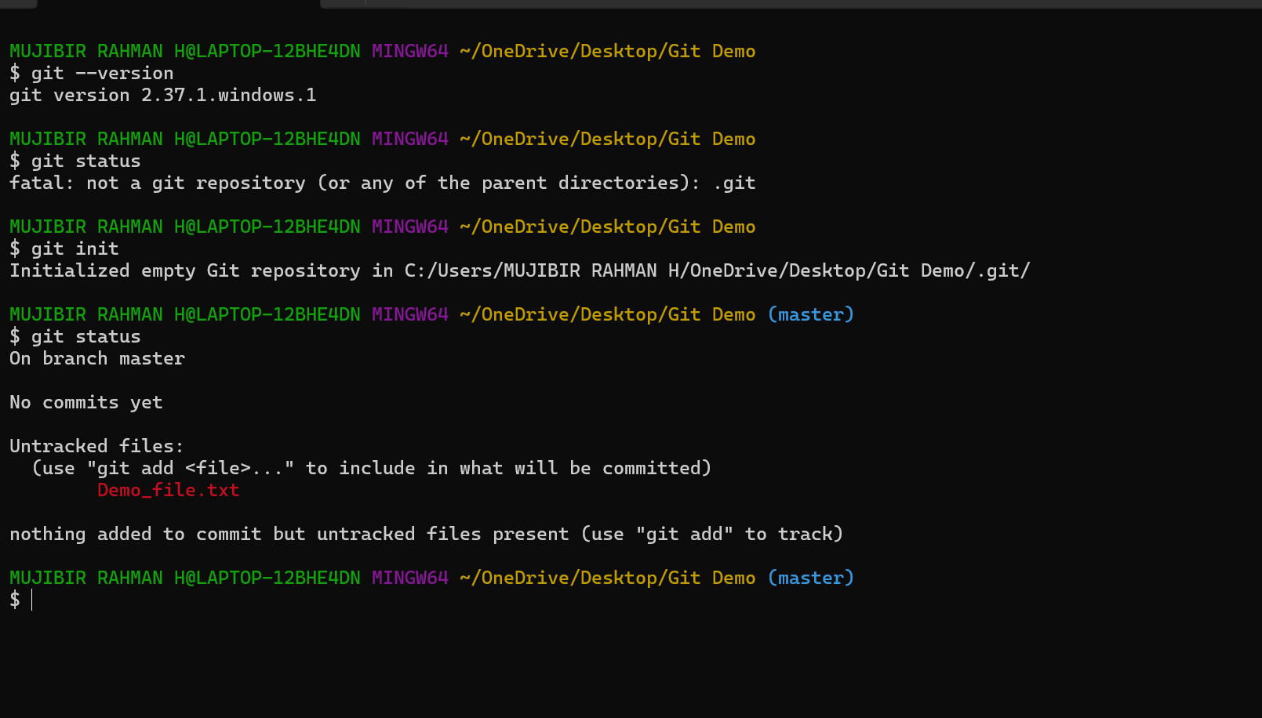
git –version
This command will help us to see the version of the git which we installed.
git init
Once installed the git, that’s not sufficient. We need initialize the git. That Is the reason we are using this. After initialization, We are able to see /.git in the path.
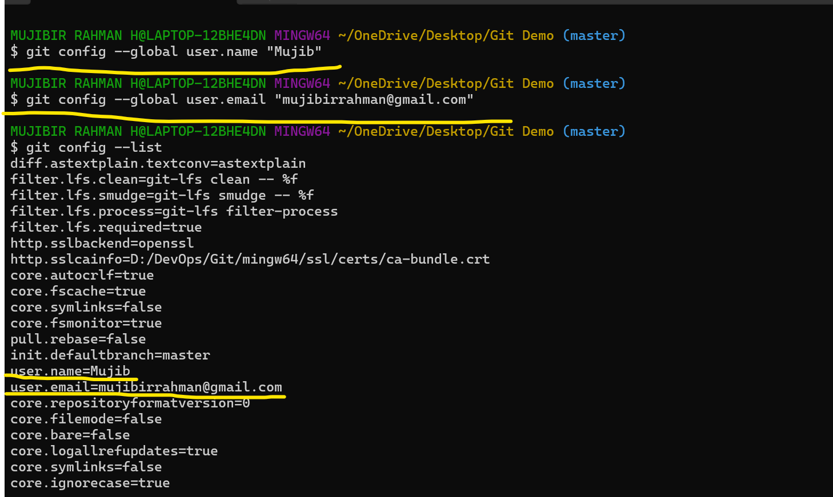
Using below command to add username, and user email
git config – global user.name “Name ”
git config – global user.email “E_Mail ”
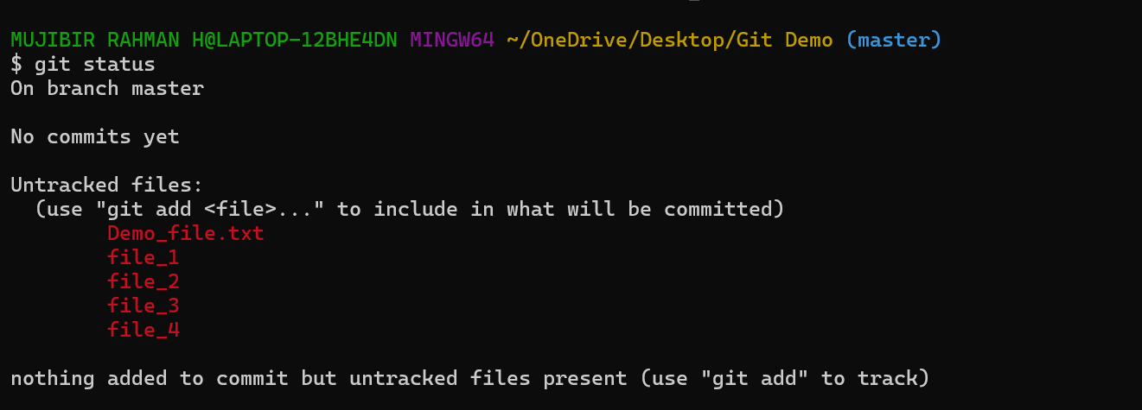
git status Will help us to get the status
I am using this,
git add . to Untracking to tracking by the git. After, changing into tracking, we can commit and push the source code to Git hub.
git commit -m “message” This command will help us to commit the changes.
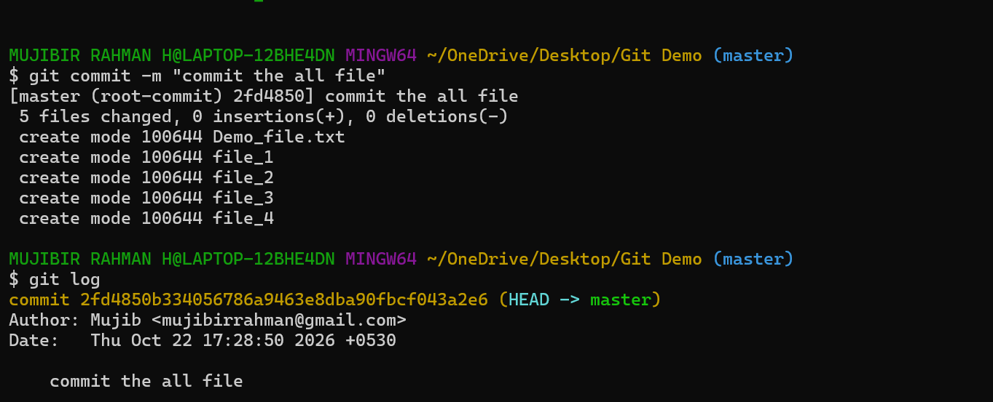
git log This command will help us to get the logs/information. We can easily find the commit id here.
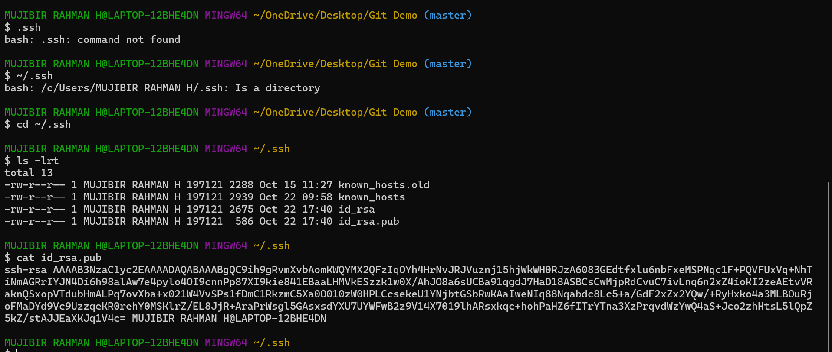
while pushing the source code to github, Will facing some error like permission denied. We need to add our ssh keygen to Github
We need to set the destination path – i.e., We need to create a repo and get the ssh link & add that into
git remote add origin ssh_Link
Now, We execute git remote -v Will able to see destination path.
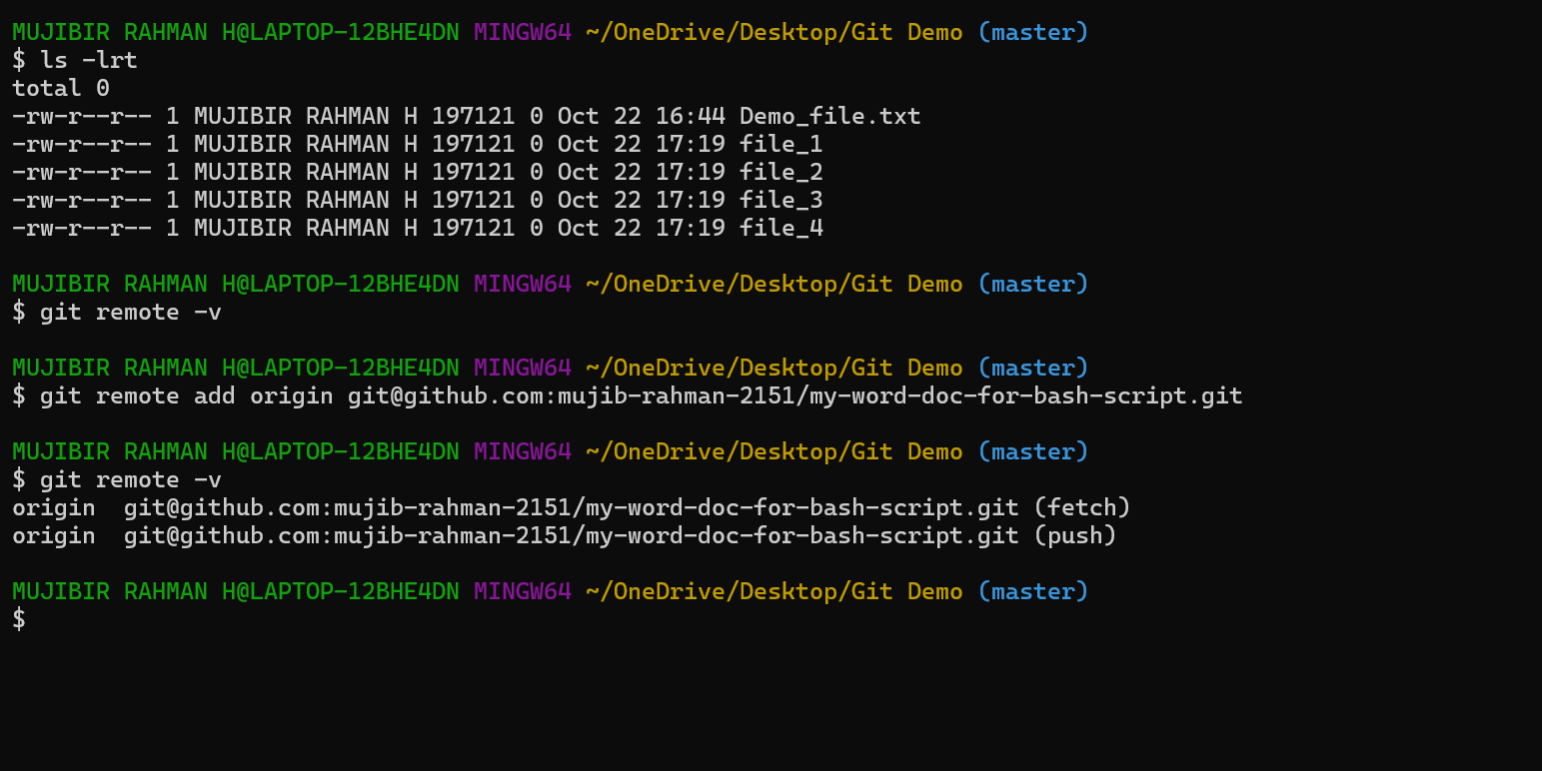
Now, we will able to push the code to github. Pre requisite are ssh-keygen pair needs to be added, destination path we need to determine before push the source code to github.
git push -u origin master This is the command for push the source code to github.
